Title of the paper
(capital letters, times new roman, 14 pt, BOLD, Centered)

CONFERENCE PAPER TITLE IN ENGLISH (if the title is in another language), Scientific degree, authors name and surname, place of work (Times New Roman, 12 pt, centered text)

Abstract: (in English, font Times New Roman, 11 pt, Justify, not more than 300 words or 1900 characters). The development of internet technologies and the improvement of e-learning platforms has placed the instructor in an entirely new role. Electronic learning is designed for self-study, consistent with students’ characteristics and allowing them to manage their own learning process. This way, the teacher can leave the field of the “knowing it all” and transfer into becoming a tutor who can support the learning path of students using internet communication technologies. Such a shift unveils the controversial status of the teaching institution in a world of digits, which is additionally complicated by the advent of Y and Z generations in higher education known as “digital natives” who can perfectly handle the use all electronic devices and their countless applications as compared to the inability of many of their professors. Despite the skepticism in the academic world towards the use of electronic platforms instructors have not lost their importance but on the contrary, their responsibility has even increased in their new role of being competent guides to students in the sea of information and resources available in cyberspace.
Key words: competency; informal learning; e-learning; tutor; effectiveness
(Times New Roman, 11 pt, Justify)

Times New Roman, 12 pt, Indentation: First Line 1 cm
The paper should be formatted with the following characteristics: size of page 21 см × 29,7 см (А4), Top: 2 сm, Bottom: 2 сm, Left: 3 сm, Right: 2 сm; Font Times New Roman, 12 pt, Justify, Spacing – 1 (Single) and indent from the first paragraph 1 сm (First line). Maximum number of pages should be 6 (six) standard typed pages (1800 characters/page), including the title, abstract, tables, figures and bibliography. Pages should not be numbered.
Papers should be sent on the following website: http://roundtable.mu-varna.bg/bg.
The Organising Committee will publish papers that meet the scientific requirements, are thematically focused as per the conference subject areas, and have been approved by the reviewers. In order to meet the requirements for formatting we recommend you directly format your paper using the template which has been designed according to them.
Citations in the text should be done as follows (Ivanov, 2000:35) which corresponds to the author’s last name, year of publication for the cited source should appear in parenthesis, and the page number should be inserted after the colon. When referencing, please indicate only the year of issue. One complete reference for each source appear in the reference list at the end of the paper.
Explanatory notes (footnotes) should be positioned on the same page and special emphasis should be italicized (Italics).

Figures and tables
The figures and tables should be separated from the main body of the text by a single space. The tables and figures should be numbered, captions should be provided in bold, and images should be centered. Figure captions should be written below them and centered:

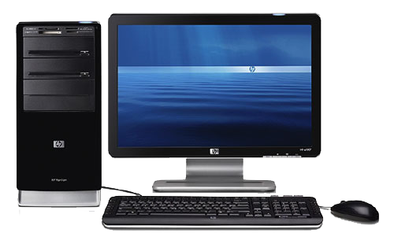

Fig. 1. Caption.

Table captions should be written above. The text should be 10 pt, Times New Roman. The captions for labelling the columns should start with a capital letter (see the example)

Тable 1. Title
Main group |  | Types |  |  | Result

REFERENCES AND RESOURCES
Font: Times New Roman, Size: 10, Alignment: Justified. The reference list should be the last page of your paper and alphabetized – references first in Cyrillic and second in Latin script. APA Format Citation standard should be used (http://www.mendeley.com/com/guides/apa-citation-guide).

Examples:

Пийз, Алън и Барбара Пийз (2012) Езикът на тялото на работното място, София. Сиела
Руменчев, Величко (2006) Невербална комуникация в публичната реч и деловото общуване, София: УИ „Св. Кл. Охридски“, С. 135
Cameron, E., Green, M. (2015). Making sense of change management: A complete guide to the models, tools and techniques of organizational change. Kogan Page Publishers.
Avolio, B. J., Bass, B. M., & Jung, D. I. (1999). Re‐examining the components of transformational and transactional leadership using the Multifactor Leadership. Journal of occupational and organizational psychology, 72(4), 441-462

Electronic sources:
Author, publication title, year of publication, web-address, date of retrieval
Mitchell, J.A., Thomson, M., & Coyne, R.P. (2017). A guide to citation. Retrieved from https://www.mendeley.com/reference-management/reference-manager
Mitchell, J.A. (2017, May 21). How and when to reference. Retrieved from https://www.howandwhentoreference.com.

Author contact details:

Address:
Тelephone number:
Е-mail:

